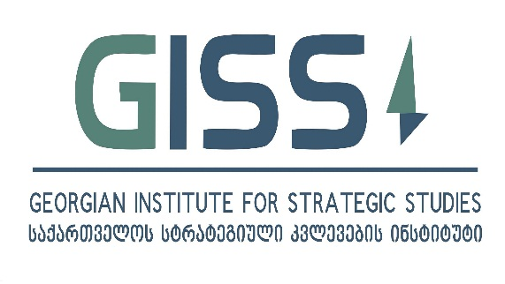

The Tbilisi Transformational Leadership Forum (TTLF) 2016
Project Outline

The purpose of the project is to design a leadership program for young leaders from the EaP and EU member states to share the experience and knowledge about the EU integration processes and related transformations that took place in the EU member states as well in some of the EaP countries.
The project will gather young professionals from the Eastern Partnership (EaP) and the EU member states with demonstrated leadership credentials in order to enhance their understanding of transformational processes in Europe, as well as their knowledge of regional foreign policy dynamics, including economic and energy security considerations for Caucasus, the Black Sea Region and wider Europe. On a personal Level TTFL 2016 will enable participants to develop close ties and will form a network of like-minded young leaders from the EaP and EU member states.
Overall objectives of the project include the following:
- To provide comprehensive view on EU integration related reform agenda. The Forum will focus on the broad spectrum of transformational processes in political, social, institutional, as well as security and economic areas that took place or continue to take place in the EaP countries as well as EU member states.
- To expand a network of leaders (alumni) who can inspire positive changes back in their countries. The TTLF will give participants the opportunity to share experiences of their countries related to transformational processes. The pool of the Participants (alumni network) will be a recurrent asset that can benefit future projects carried out by the program participants as well as donors.
- To create a sustainable platform for young leaders of EaP countries aimed at strengthening their capacity to contribute to the democratic development of their countries as well as their approximation with Europe. GISS aims to hold TTLF on an annual basis and to expand the geographical reach of the project by including participants from a larger number of EU member states.
- To promote reform agenda in EaP countries aimed at their democratic development as well as approximation with Europe.
The primary target groups of the project include:
- The young professionals: Leaders aged 24-35 years. The forum will bring together 20 young leaders.
- Lecturers, officials and experts
- The general public
There will be 2 participants from each EaP country and 2 participants respectively from each of the following countries: Sweden, Estonia, Lithuania and Poland.

The project will be divided into two phases and will consists of representative sets of activities.
The first phase will include a 4-day lecture/workshop series that will be hosted by Georgian Institute for Strategic Studies (GISS) in Tbilisi, Georgia. Speakers with an extensive experience and expertise will engage with participants on the following topics: Political, social, security and economic transformations in the EaP countries as well as EU member states, regional political and foreign policy dynamics, models of economic development etc.
The Second phase will be a study trip to one of the EU members states (Sweden), where participants will have a chance to interact with local opinion-makers and practitioners in order to get a first-hand exposure to the best practices associated with this country. The duration of the second phase will be 3 days. The aim of the study trip to Stockholm, Sweden is to familiarize participants with the successful reforms in Sweden as a consolidated democracy with successfully functioning economic model, Sweden’s foreign policy priorities as well as its view of the best practices of policy-making in the EU. The study tour programme will include meetings with government officials, representatives of NGOs and practitioners from the private sector.

